Assignment No. 8

Names:
Kaustubh Jaitapkar – 22510113
Harshavardhan Bamane - 22510112
Class : TY CSE
Batch : T6

Steps :
Architecture Overview
For a basic three-machine MySQL NDB Cluster setup, the roles are:
- Machine 1: Management Node (ndb_mgmd) 10.40.0.216
- Machine 2: Data Node (ndbd) 10.40.13.63
- Machine 3: SQL Node (mysqld) 10.40.0.94
Step 1 : Installation from mysql website
Step 2 :
Configuration on management node :
create a config file:

1. Open Notepad and save it as:
arduino
CopyEdit
C:\mysql-cluster\config.ini

2.Add the following content:
ini
CopyEdit
[ndbd default]
NoOfReplicas=2
DataMemory=80M
IndexMemory=18M
[ndb_mgmd]
Hostname=10.40.0.216
DataDir=C:\mysql-cluster

[ndbd]
Hostname=10.40.13.63
NodeId=2
DataDir=C:\mysql-cluster\data

[mysqld]
Hostname=10.40.0.94

3.Start the Management Node
Open Command Prompt (Admin) and run:
sh
CopyEdit
ndb_mgmd -f C:\mysql-cluster\config.ini

Config data node :
Open Notepad and save it as:
makefile
CopyEdit
C:\mysql-cluster\my.ini

Add the following content:
ini
CopyEdit
[mysqld]
ndbcluster

[mysql_cluster]
ndb-connectstring=10.40.13.63

Start the Data Node
Open Command Prompt (Admin) and run:
sh
CopyEdit
ndbd

Config SQL node :
Open Terminal and edit my.cnf:
sh
CopyEdit
sudo nano /usr/local/etc/my.cnf

Add the following content:
ini
CopyEdit
[mysqld]
ndbcluster

[mysql_cluster]
ndb-connectstring=10.40.0.94

Restart MySQL:
sh
CopyEdit
brew services restart mysql

Screenshots: 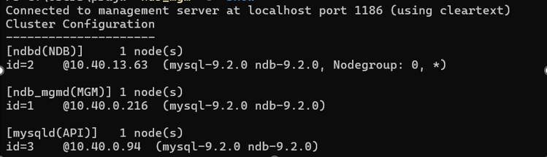

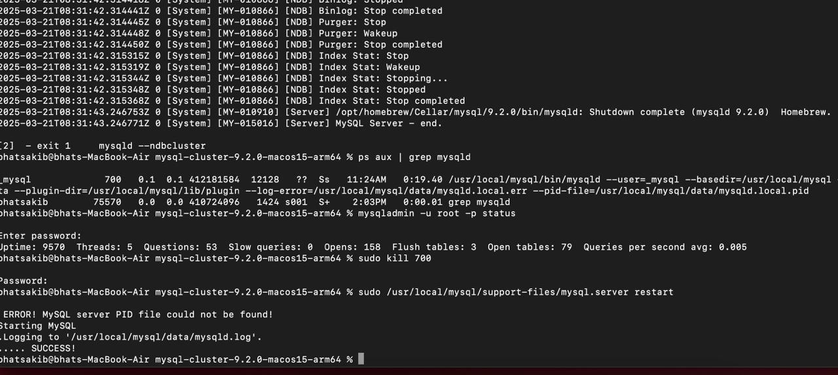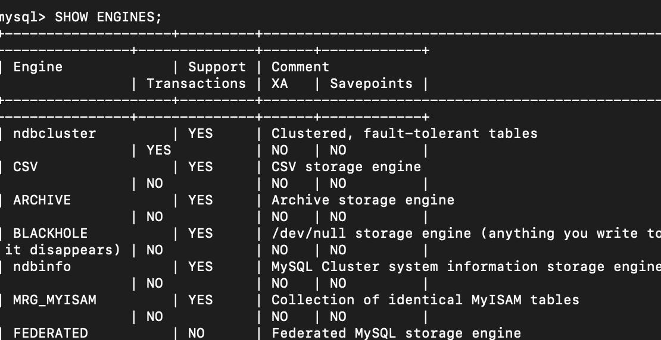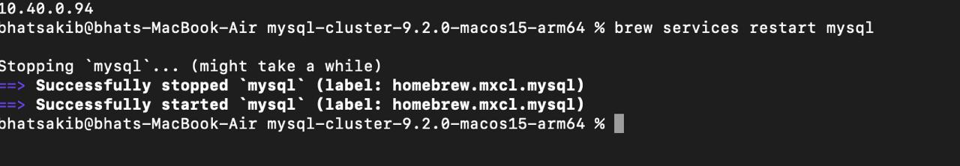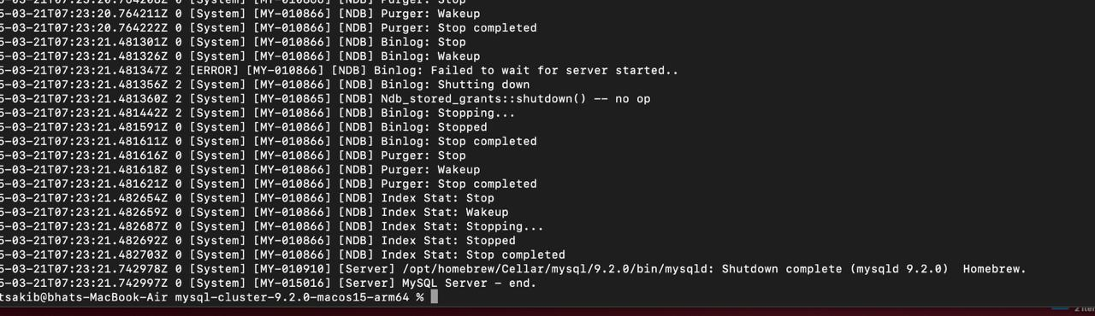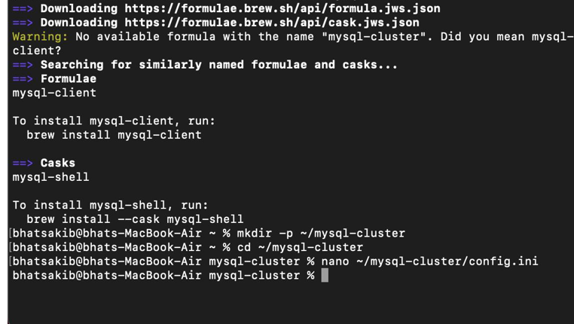

Running application on clustered database:
